ANOVOS – Installation & Run

This document contains the following sections -

1. Docker Installation
2. Configuring Docker Settings
3. Downloading Docker Image
4. Running Docker Image
5. Downloading Anovos Report
6. Direct Installation & Run
7. Post Workshop Cleanup Steps

# Docker Installation

To get started straight away, install Docker on your machine

## **For Windows 10 Pro / Mac OS X / Linux**

1. Visit <https://docs.docker.com/engine/install/> and download Docker for Mac or Windows.  
   1. Windows OS - <https://docs.docker.com/desktop/windows/install/> or <https://hub.docker.com/editions/community/docker-ce-desktop-mac>
   2. For Linux Distributions - <https://docs.docker.com/engine/install/>
   3. Mac OS - <https://docs.docker.com/desktop/mac/install/> or <https://hub.docker.com/editions/community/docker-ce-desktop-mac>

Note: For Mac OS your machine maybe one of two hardware chips - either Intel chip or Apple chip (M1). The hardware chip information can be found by clicking on the Apple logo in the menu bar and choosing *About This Mac* *=> Overview* as seen on Figure1, 2   
  
If it is intel chip-based Mac then we suggest going ahead with Docker Installation in above link by choosing Intel chip when downloading docker desktop.   
  
If it is Apple-chip based Mac (M1) then we suggest skipping the following sections : . and doing section 1. ANOVOS Local Installation for Direct Installation to install Spark, Python and run Anovos directly in local without using docker.   
  
This is due to recent issues reported for running tensor flow in docker containers on M1 machines specifically.  
  
Figure Sample Intel Chip Information

Figure Sample Apple Chip Information

1. Follow the onscreen instructions on the website to install Docker on your machine.
2. Start Docker.

## **Confirm Docker Installation**

Once installed, open a command-line terminal (like PowerShell in case of Windows OS). The following commands can help confirm docker is installed and running correctly.

1. Run docker version to show the docker version.
2. Run docker image ls to show list of images.
3. Run docker ps to show list of current running containers.
4. Run docker ps -a to show list of all containers

Figure Sample Screenshot showing Docker commands on Terminal

# Configure Docker Settings

Once Docker is installed, next step is to configure your machine to allocate adequate resources to it to run Anovos.

The following resources are recommended minimally for Anovos to run:

|  |  |
| --- | --- |
| Setting | Recommended Value |
| CPUs | 6 |
| Memory | 8.0 GB |
| Swap | 1 GB |
| Disk Image Size | 24 GB |

The **Resources** tab in docker desktop (for MacOS and Windows) allows you to configure CPU, memory, disk and other resources. Please find the screenshot below for the same:

Figure Screenshot showing preferred Docker Resource Allocation

Documentation :   
<https://docs.docker.com/desktop/windows/#resources> (Windows)  
<https://docs.docker.com/desktop/mac/#resources> (Mac OS)

Note : For native Linux distributions, Docker can run using all available host memory. There isn't a control or setting to limit or increase this. So the above setting is not applicable.

# Downloading Docker Image

Once the docker installation and resource allocation steps have been completed, the next step is to download the Docker image for the workshop.

Run the following command on command line to download the latest workshop docker image -   
docker pull anovos/anovos-workshop:latest

Once the image has been successfully pulled, kindly confirm by listing the images in your machine   
docker image ls

Please find the screenshot below for the same:

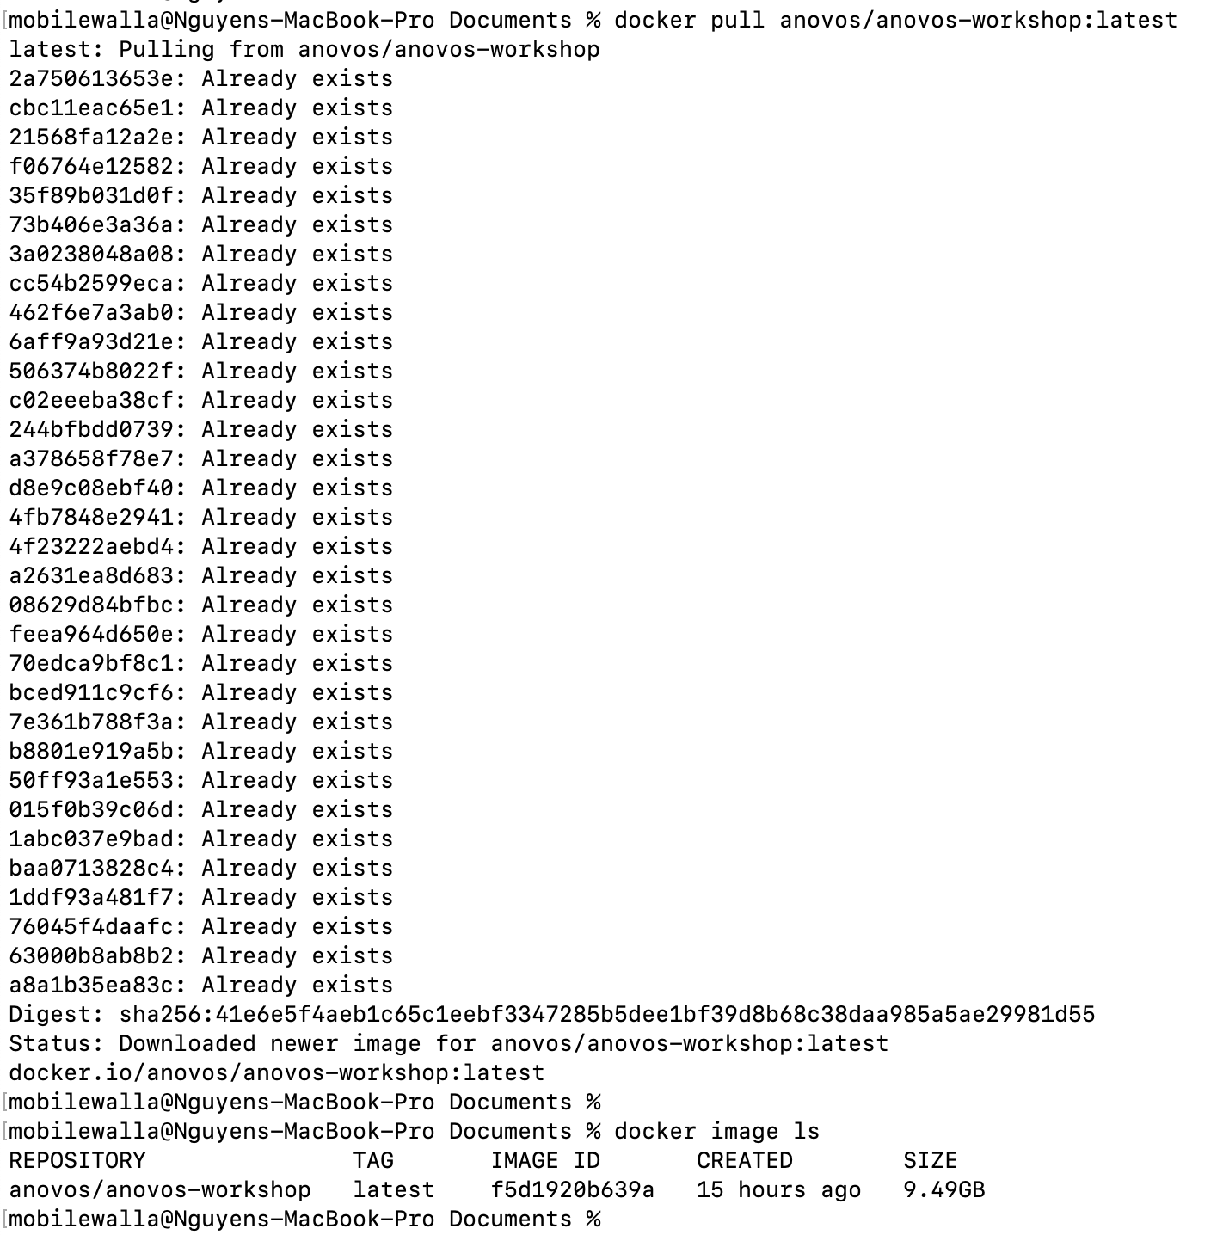

Figure Screenshot showing docker image successfully pulled to local

It is recommended to download the docker image in advance before the workshop to save time as the image size is ~10GB and could take a while to download.

# Running Docker Image

The final step is to run the docker image.  
Note: This step is to be done during the planned workshop/tutorial

Run the following command on command line to run the docker image –   
docker run --name anovos_workshop -p 9999:9999 anovos/anovos-workshop:latest  
  
Figure Screenshot showing Docker run being executed

Open the link http://127.0.0.1:9999/?token... generated by the Jupyter NotebookApp in a browser to start the Jupyter notebook with Anovos installed.

On staring, You should see a folder titled use_case_demo/

Open anovos_use_case_demo.ipynb notebook inside the folder.

Figure Anovos Use Case Demo Notebook

*!!! Enjoy exploring ANOVOS !!!*

# Downloading Anovos Report

Anovos has the capability to generate multiple HTML reports such as Basic Report and Full report as part of its functions.

This will be explained thoroughly in detail during the workshop.

The reports can then be copied to the local machine from the Docker containers using the following command –   
  
docker cp container-name:<path in container> <local_path>

For example, to copy basic_report.html from the path - /anovos/use_case_demo/data/output/data_report/report_stats/basic_report.html in container anovos_workshop to local, the following command can be executed

docker cp anovos_workshop:/anovos/use_case_demo/data/output/data_report/report_stats/basic_report.html ./basic_report.html

The downloaded reports can then be opened in a browser (Google chrome

Figure Sample Screenshot of Anovos Basic Report

# Direct Installation & Run

## Note - Kindly skip this step if installation of Docker and run by Docker was successful.

However, for certain cases where a docker based run is not feasible (such as Mac OS on Apple Chip M1 machines),

Kindly install Anovos directly onto the end machine along with the required environment.   
  
Anovos requires installation of supported Python, Java and Spark version as specified in the link.  
  
Python Installation - <https://www.python.org/downloads/>

Spark Installation - <https://spark.apache.org/downloads.html>

Java Installation - <https://docs.oracle.com/en/java/javase/11/install/overview-jdk-installation.html#GUID-8677A77F-231A-40F7-98B9-1FD0B48C346A>

Anovos Installation - <https://github.com/anovos/anovos#using-anovos>

Also, for this workshop kindly install Jupyter Notebook as well - <https://jupyter.org/install>

Once all the above installation is done, kindly download the following .tgz to a local path and extract the tgz - <https://mobilewalla-anovos.s3.amazonaws.com/workshop/use_case_demo.tgz>   
  
Open the folder on a Jupyter notebook local instance and start anovos_use_case_demo.ipynb

# Post Workshop Cleanup

Once you have finished exploring Anovos, kindly stop the running docker container on command line by running docker stop anovos_workshop in a new terminal tab.

Then kindly check if there are no running containers using the command -   
docker ps

and if the anovos-workshop container has exited properly using the command -   
docker ps -a should show status as Exited (0)

Remove the old container using the command -   
docker rm anovos_workshop

The image would still be loaded and by just following #4 Running Docker Image again, we can start a new container with Anovos installed.

If you choose to remove the image entirely from the system, kindly use the following command -   
docker rmi anovos/anovos-workshop

Figure Screenshot showing steps to remove Docker container